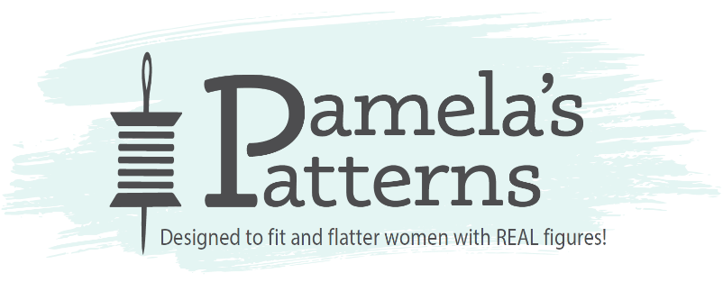

**Fit Fashion Patterns - Overcome Fitting Problems Without a Muslin!**

**Pamela Leggett, Instructor**

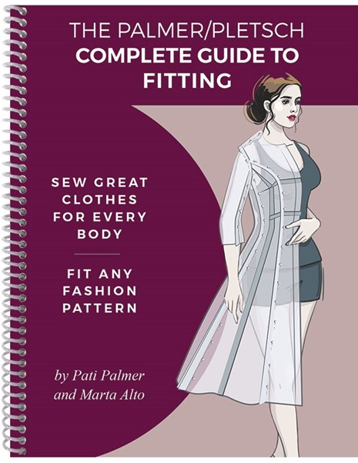

Finally, a class that will empower you to fit yourself and others to be successful sewing any garment you would like! Pamela, a certified Palmer/Pletsch Fit Specialist, will show you how to determine your pattern size, and how your body type varies from most commercial patterns. This class will address fitting issues found in most women such as forward shoulder, high round, narrow/broad and sway back, full bust and/or torso, large arms, and much more. You will also learn about fabric “tweaking”, princess seam adjustment and dart rotation.

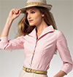**Supply List**

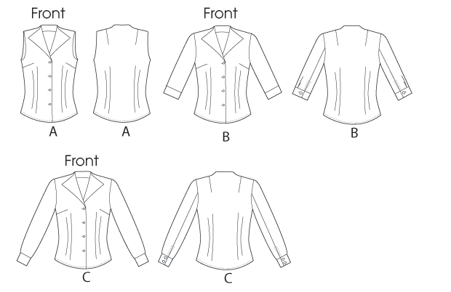For this workshop you will all work with the same pattern, McCall’s #6750, from Palmer/Pletsch. This versatile pattern will help you learn important skills which can then be used on any pattern of your choice.

**Choosing the Correct Size Pattern (just get as close as you can!)**

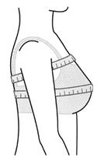It is important for you to know how to measure so that you will purchase the correct size pattern. Your pattern size is based on your high bust measurement rather than your full bust measurement. When you take the high bust measurement, it is important to have the measuring tape snug to your body, without outerwear on. Place the tape measure just under your shoulder blades in the back, high up under the arm, and above the bust. This is called a skin measurement. If you fall in between sizes, it is usually a good idea to go to the smaller size, unless you have a very broad back.

McCall’s Size Chart

**Pick your pattern size by the high bust measurement**

6 8 10 12 14 16 18 20 22 24

30 ½ 31 ½ 32 ½ 34 36 38 40 42 44 46

**Also Bring:**

* Scotch Magic Tape in a weighted dispenser
* Rotary cutter, ruler, cutting mat (pinnable), or a cardboard cutting mat
* Palmer/Pletsch book, Complete Guide To Fitting and Palmer/Pletsch Pattern Paper (these will be available to purchase at the class)
* Scissors, tape measure, any fashion rulers you own, fabric marker or chalk, pattern weights.
* Flair felt marker by Paper Mate (any color except black). These markers don’t bleed through the paper.
* Pins – these should be nice thin pins with a small head. Glasshead pins are the best!
* Wear a camisole or close fitted sleeveless top and your best fitting bra.
* 2 ½ yds blouse weight fabric (this is optional. I am hoping to demonstrate on one or two people how the fabric fitting and tweaking works)

I am looking forward to working with you. Pattern fitting is one of my very favorite things to teach! See you at the workshop!